**ECE 457**

**Fall 2019**

**Preliminary Design Review**

**ECE – 6 TV Auto Commercial Mute System (MuteBot)**

**Report Submitted: December 9, 2019**

We, the undersigned, certify that we contributed to the generation of this report and attest to the validity of the data herein:

**Team Members:**

Steven Ferreira _____________________

Thomas Morrissey _____________________

Kevin Prairie _____________________

Zachary Taylor _____________________

**Customer:**

Dr. Paul J. Fortier

**Advisor:**

Dr. David P. Rancour

**Table of Contents**

Abstract 4

1 Introduction 4

2 System Diagrams 4

2.1 Concept of Operation 4

2.2 Functional Architecture Diagram 5

3 Customer Requirements 6

4 Engineering Requirements 7

4.1 Constraints 9

5 Standards 10

6 Resource & Cost Summary 11

7 Prototyping 13

7.1 IR Communication 13

7.2 Commercial Detection 17

7.3 Solidworks 19

8 Risk Analysis 19

9 Schedule 21

10 Earned Value 27

A Appendix 28

**List of Tables**

Table 1: Customer Requirements 7

Table 2: Customer to Engineering Requirements 8

Table 3: Resources Summary & Cost 12

Table 4: IR prototyping problems and mitigation 18

Table 5: Potential Problems & Risk Analysis 21

Table 6: Earned Value for the SRR and CDR 28

**List of Figures**

Figure 1: Concept of Operation 6

Figure 2: Functional Architecture Diagram 7

Figure 3: Geekworm IR expansion board and universal remote 14

Figure 4: IR configuration file 1 15

Figure 5: IR configuration file 2 15

Figure 6: LIRC commands and IR pulses 16

Figure 7: Westinghouse Remote config file 17

Figure 8: .wav file Python plot 19

Figure 9: Real-time Python plot 19

Figure 10: Solidworks Prototyping 20

Figure 11: System Requirements Review Schedule 22

Figure 12: Concept Design Review Schedule 23

Figure 13: Preliminary Design Review Schedule 24

Figure 14: ECE 457 Full Schedule Part 1 25

Figure 15: ECE 457 Full Schedule Part 2 26

Figure 16: ECE 457 Full Schedule Part 3 27

# Abstract

The TV Commercial Auto-Mute system, or MuteBot, is being created to combat the initial volume spike that commercials use to quickly grab the attention of a viewer. After taking the advice of Dr. Viall when consulting him on commercial detection. The system has gone through some design changes. Instead of attempting to integrate audio cues and video cues, the team will now focus on combining multiple audio cues to detect upcoming commercials. This design change took up much of the prototyping time due to the new research needed to be done to finish the preliminary design. During this phase the remote-control system and enclosure via Solidworks were also worked on, but due to time constraints and roadblocks there is still work to be done.

# Introduction

Since the Concept Design Review, the requirements, constraints and standards have stayed the same. At this stage of the project, several decisions have been made for the subsystems and major components of the system. Components have also been chosen and purchased for prototyping during this phase of the project. Using Python, scripts were made in order to read and plot audio sources. Using LIRC (Linux Infrared Remote Control), the transmission and reception of signals was worked on for the remote-control system. Going into the Winter break and based upon the prototyping done thus far, the team has a good understanding of the steps that need to be taken to continue making progress next semester.

# System Diagrams

For the Preliminary Design Review, the MuteBot system diagrams are used to provide a general overview of how the system should operate. The MuteBot system was broken down into different subsystems for prototyping including IR communication, commercial detection, and the physical design of the system’s housing.

## Concept of Operation

The design displayed in Figure 1 is a concept of operation. This design provides a general external overview of the design project. It highlights where the system should connect into an existing entertainment center set-up as well as what each component in the system should be doing. The system is perpetually powered by a standard US 120-volt wall outlet. The system initiates when the power button on the infrared remote is pressed. Once this is activated, the MuteBot will begin running its detection algorithm. It will begin this process by taking 3.5mm audio signals and sending them to the processor for real-time processing. Once the algorithm senses what it believes to be a commercial, the MuteBot will mimic the IR mute signal of the TV brand, which will result in the TV being muted. When the MuteBot believes the TV programming has returned the MuteBot will mimic the same signal to unmute the TV.

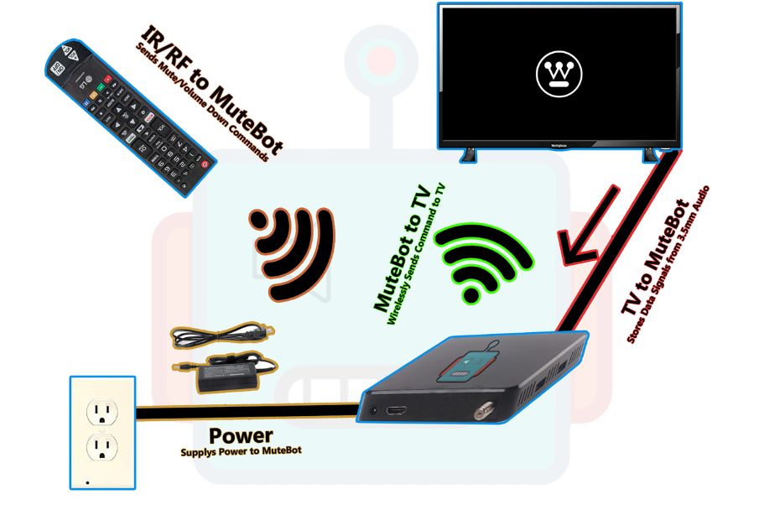

Figure 1: Concept of Operation

## Functional Architecture Diagram

In Figure 2, a functional architecture diagram is used to give a full overview of the subsystems and components that will make up the full MuteBot system. The full system has been broken down into 3 main categories: Signal Processing & Volume Control, Mounting System, and the Remote Control. Within each subsystem includes different componenets and aspects needed to meet the customer requirements for the system. Since the CDR, the processor of choice, and TV interface of choice have been updated to the Raspberry Pi 3B and the 3.5mm headphone jack to reflect the current design of the MuteBot.

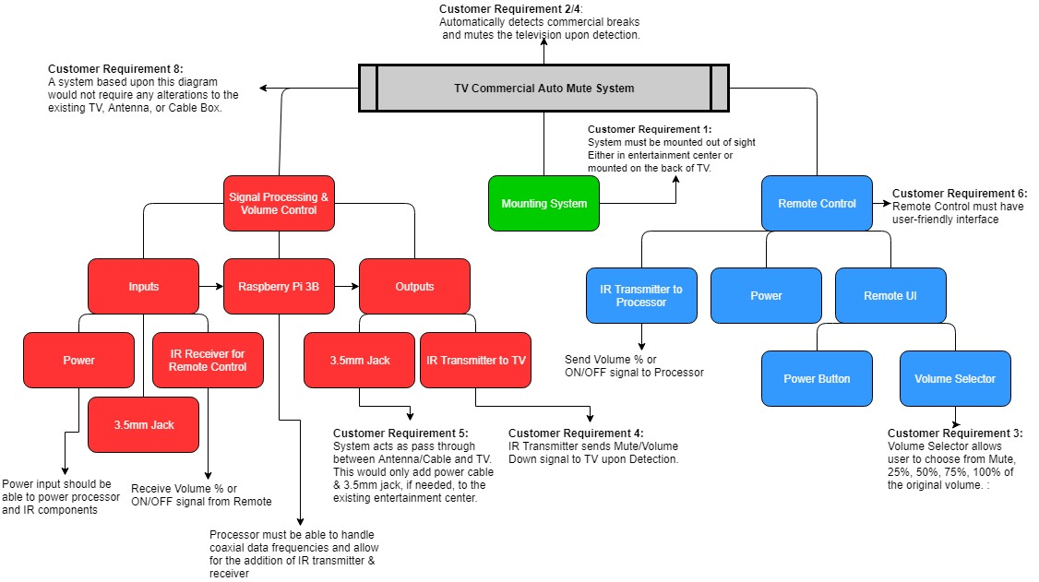

Figure 2: Functional Architecture Diagram

# Customer Requirements

Table 1 provides the customer requirements for the MuteBot system. Since the Concept Design Review, the customer requirements for the MuteBot have not changed. However, the second requirement is subject to change due to the unknown difficulty of delaying a live television broadcast and if it will be needed using the commercial detection methods that the team plans to use. More research and prototyping need to be done to determine the feasibility and necessity of the delay before the requirement is updated or removed.

Table 1: Customer Requirements

|  |  |
| --- | --- |
| Customer Requirement Number | Requirement Description |
|  | System must not obstruct the TV Screen. It must be able to be kept out of sight. |
|  | System must appear preemptive to the user, but can delay the broadcast by 10 seconds for improvement of accuracy. |
|  | System must allow user to choose to mute completely or lower volume when a commercial is detected. |
|  | System must mute or lower volume upon break and unmute or return to original volume upon return. |
|  | System must be simple to initially set up. |
|  | System must have a user-friendly interface/remote. |
|  | System cost must be competitive with competition. |
|  | System must refrain from any alterations to the TV or its remote control. |

# Engineering Requirements

Table 2 takes the customer requirements described in Table 1 and breaks them down into quantifiable and testable engineering requirements. The engineering requirements have not changed for the system since the Concept Design Review. Such as with the customer requirements, engineering requirement 2 is subject to change until more research and prototyping is done to gain a better understanding of the delay. The questionnaire created for user-review tests has also stayed the same since the last report and can be found in Appendix A.

Table 2: Customer to Engineering Requirements

|  |  |  |  |  |
| --- | --- | --- | --- | --- |
| Rqmt. # | Customer Requirement | Engineering Requirement | Justification/Comments | Test Method (IADT) |
|  | System must not obstruct the TV screen. It must be able to be kept out of sight. | System can have a cable box at most, rest of system must remain behind the TV. | The system must not be obtrusive to ensure the user has a clear and not obstructed viewing experience. | Inspection:  User-Review/Observation  This will be measured via a questionnaire. Any category in the questionnaire labeled 3 or lower will be deemed not acceptable and the next step for improvement. |
|  | System must appear preemptive to the user, but can delay the broadcast by 10 seconds for improvement of accuracy. | System must mute to 0 dB before at least 1 millisecond before commercial break appears before the user. | The system must mute preemptively in order to ensure a smoothing viewing experience for the user. | Test:  Use Audacity or other audio editing program to measure average decibel value over a time sample of 1 minute and time passed before mute was engaged. |
| 2.1 |  | System will delay the live broadcast by at most 10 seconds. | This delay allows for an increase rate of accuracy due to being able to have a larger sample size. | Test:  Use two different TVs, one with MuteBot Connected, one without MuteBot connected. Use a stopwatch to test the time difference between the same frame. |
| 2.2 |  | System must lower volume a percentage lower before at least 1 millisecond before commercial break appears before the user. | The system must abide by the user’s selection. | Test:  Use Audacity or other audio editing program to measure average decibel value over a time sample of 1 minute and time passed before mute was engaged. |
| 2.3 |  | When returning from break the TV must return to the original dB volume before the commercial break at least 1 millisecond before returning to the live show appears before the user. | The system shouldn’t alter the original programming at all as that is not the intent of the system and not preemptively returning the volume will result in a disturbance in the user’s experience. | Test:  Use Audacity or other audio editing program to measure exact decibel value and time passed after mute was disengaged. Measure average decibel value over a time sample of 1 minute after disengagement to ensure volume returned to original value. |
|  | System must allow user to choose to mute completely or lower volume when a commercial is detected. | The system must have a user interface that enables the user to choose between a volume of 0% (mute), 25%, 50%, 75%, 100% (off). | Giving options to the user allows for a more customizable experience. | Inspection:  Ensure quality of UI by user-review.  This will be measured via a questionnaire. Any category in the questionnaire labeled 3 or lower will be deemed not acceptable and the next step for improvement. |
|  | System must mute or lower volume upon break and unmute or return to original volume upon return. | System must lower the TV to 0 dB if that percentage is chosen. | The mute system is to ensure the user comfort by allowing the manipulation of volume. | Test:  Use Audacity to ensure the average decibel value over 3 minutes is 0 dB. |
| 4.1 |  | If lower volume is chosen the system must lower the TV’s volume by the percent chosen by the user. | Same as above. | Test:  Use Audacity to ensure the average decibel value over 3 minutes is the chosen value less than the measured programming volume. |
|  | System must be simple to initially set up. | The engineers are only to assume the users know how to: plug in an HDMI cord, | If the system is similar to design to a TV, then the user will find it easier to work with something of similar design. | Inspection/Demonstration:  User-Review/Test Subject  This will be measured via a questionnaire. Any category in the questionnaire labeled 3 or lower will be deemed not acceptable and the next step for improvement. |
| 5.1 |  | Power Cord, | Same as above. | Same as above |
| 5.2 |  | Interface with a TV remote | Same as above. | Same as above |
|  | System must have a user-friendly interface/remote. | The user interface must not consist of anything that would not already be on a TV remote or cable box. | A simple user interface allows ease-of-use and broadens the potential consumers. | Inspection/Demonstration:  User-Review/Test Subject  This will be measured via a questionnaire. Any category in the questionnaire labeled 3 or lower will be deemed not acceptable and the next step for improvement. |
|  | System cost must be competitive with competition. | The system must remain anywhere from $40 - $100 retail cost. | A low retail costs attracts more customers and makes the product more able for mass production. | Analysis:  Components and materials cost will be analyzed using Excel. The final product will be compared to competition (MuteMagic, MuTR) |
| 7.1 |  | Thus, the manufacturer cost is estimated to be between $24-$67. | A lower manufacturer costs aims for a larger profit. | Analysis:  Same as above. |
| 8. | System must refrain from any alterations to the TV or its remote control. | The TV and remote must remain the same as originally purchased. | Altering the TV or remote would require too much of the user and is not fit for mass production. | Inspection:  User-Review  This will be measured via a questionnaire. Any category in the questionnaire labeled 3 or lower will be deemed not acceptable and the next step for improvement. |

## Constraints

The list below shows the seven constraints for the MuteBot system. The constraints have not been changed since the Concpet Design Review, but as the team progesses throughout next semester, any updates or changes will be highlighted.

1. Form Factor (Same size or smaller than an Apple TV or Roku Ultra)

* Apple TV: Height-1.4 in, Width-3.9 in, Depth-3.9 in
* Roku Ultra: Height-0.8 in, Width-4.9 in, Depth-4.9 in

1. TV cannot be altered or changed in any way (Removing or modifying parts or remote)
2. Location- should not be visible (mounted to the back of the TV)
3. Inputs on the TV (HDMI, coax)
4. Outputs on the TV (Digital Optical Audio cable, 3.5mm Jack)
5. Budget-must be in same price range as the competitors (MuteMagic $39.95, MUTR $30 with a subscription of $50 per year)
6. Television provided (Westinghouse HDTV)

# Standards

The standards for the Mutebot system have not been changed since the CDR. The list below shows the current standards for the system, but as we progress throughout next semester and conduct more prototyping, these standards may be updated and will be highlighted.

1. CALM Act: Commercial Advertisement Loudness Mitigation Act:
   1. <https://www.provideocoalition.com/the-calm-act-commercial-advertisement-loudness-mitigation/>
   2. The FCC set and monitor the loudness of commercials. The ITU, International Telecommunication Union, created standard audio measurements for content that is being broadcasted
2. ITU-R BS.1170:
   1. <https://www.itu.int/dms_pubrec/itu-r/rec/bs/R-REC-BS.1770-4-201510-I!!PDF-E.pdf>
   2. Ways to measure commercial audio loudness and true-peak audio level
3. IEEE Code of Ethics
   1. <https://www.ieee.org/about/corporate/governance/p7-8.html>
   2. The responsibilities in which all engineers are expected to follow that are expressed in a code of ethics.
4. Betamax Case: Sony Corp. of America v. Universal City Studios, Inc.
   1. <https://www.oyez.org/cases/1982/81-1687>
   2. Ruled recording TV legal
5. Copyright Laws and Television:
   1. <https://yourbusiness.azcentral.com/copyright-laws-television-16286.html>
   2. TV cable programs have copyrights to a program that can be violated (file sharing and sales, dependent on each program)
6. HDMI Specification Version 1.4a
   1. https://www.hdmi.org/manufacturer/hdmi_1_4/index.aspx
   2. HDMI standards and specifications that define the required waveforms and video format.
7. American National Standard ANSI/SCTE 07 2006, American National Standard ANSI/SCTE 124 2006
   1. <https://www.scte.org/documents/pdf/Standards/ANSISCTE072006.pdf>
   2. Digital Transmission Standard for Cable Television
   3. <https://www.scte.org/documents/pdf/Standards/ANSISCTE1242006.pdf>
   4. Specifications and standards for the F type connector used for cable television
8. ITU-T L.1002 (10/2016)
   1. https://www.itu.int/itu-t/recommendations/rec.aspx?rec=12131
   2. Standards for external universal power adapters
9. Standard IEC958
   1. Digital audio interface, standard for digital optical audio cables
   2. <http://www.epanorama.net/documents/audio/spdif.html>
10. TRRRS Standards including P.382
    1. Standards for the 3.5mm connector
    2. P.382 TRRRS connectors for new integration including multiple sources and noise canceling
    3. https://www.itu.int/itu-t/workprog/wp_item.aspx?isn=9990
11. Infrared Data Association (IrDA)
    1. Standards and specifications for IR transmitter and receiver communication
    2. <https://www.novell.com/documentation/suse91/suselinux-adminguide/html/ch08s03.html>
12. IEEE 802.15.4-2015 - IEEE Standard for Low-Rate Wireless Networks
    1. Standard for RF modules including the 3 pin RF module
    2. Short range devices have unlicensed ISM/SRD bands like RF remotes
    3. <https://standards.ieee.org/standard/802_15_4-2015.html>

# Resource & Cost Summary

Table 3 provides an overview of the resources and cost for the MuteBot system. Resources highlighted in green text are items added to the project while resources that are highlighted in red text are items that have been removed or replaced since the CDR. These items were removed due to design choices and decisions made during research and prototyping. Resources in black text are items that have not been changed since the CDR. The Raspberry Pi 4 was replaced by the Raspberry Pi 3B due to a cheaper price and similar performance to the Raspberry Pi 4. The Geekworm IR expansion board replaced the IR and RF transmitter and receiver. This expansion board is used to control the communication between the universal remote, Raspberry Pi 3B, and the Westinghouse TV. The USB external sound adapter was added to extract audio from a 3.5mm jack and be analyized in Python with the Raspberry Pi 3B. LIRC software is being utilized to communicate between the Geekworm expansion board, IR remote, and the Westinghouse TV. The updated cost for the MuteBot system for the PDR is $96.29.

Table 3: Resources Summary & Cost

|  |  |
| --- | --- |
| Resource | Cost |
| Raspberry Pi 3 | $38.36 |
| Geekworm Raspberry Pi IR remote expansion board | $12.09 |
| Sabrent USB external stereo sound adapter | $6.99 |
| Energizer 2025 Lithium Battery | $7.43 |
| Sandisk Ultra Plus 16G GB microSD card | $10.61 |
| HDMI to VGA adapter | Supplied by Umass Dartmouth |
| LIRC (IR communication software) | Free software |
| ~~IR Transmitter & Receiver~~ | ~~$6.98~~ |
| ~~HiLetgo 315Mhz RF Transmitter and Receiver Module~~ | ~~$4.69~~ |
| ~~Digital optical audio cable~~ | ~~$5.56~~ |
| ~~PCB Fabricator~~ | ~~Supplied by Umass Dartmouth~~ |
| ~~Eagle Schematic & PCB Design~~ | ~~Software provided by Umass Dartmouth~~ |
| 5V DC Power supply | $9.00 |
| Coax cable | $4.82 |
| 3.5mm jack | $6.99 |
| Westinghouse HDTV & Remote | Provided by customer |
| TV Antenna | Provided by customer |
| HDMI Cable | Supplied by customer |
| 3D Printer | Supplied by Umass Dartmouth |
| Atmel Studio 7.0 | Software provided by Umass Dartmouth |
| Audacity | Free software |
| Solidworks | Free software |
| Total | $96.29 |

# Prototyping

For the Preliminary Design Review, the MuteBot system’s design had to address each of the engineering requirements and provide a sufficient amount of progress prototyping. Each aspect of the MuteBot system was broken down into different categories of prototyping including the IR communication, commercial detection, and the physical design of the system’s enclosure. Along with prototyping, each aspect provided problems with mitigation and future plans that will help head towards meeting every customer and engineering requirement.

## IR Communication

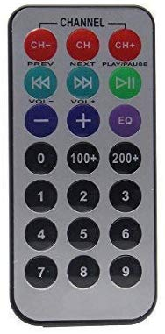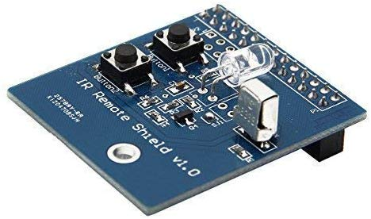For the Mutebot system, infared remote communication (IR) was chosen to communicate between the universal remote, Raspberry Pi 3B, and the Westinghouse Television. This form of communication was changed from both IR and RF to using only IR communication. This change from the CDR to the PDR was decided because the Westinghouse television communicates to the tv remote through IR and using soley IR communication would make the integration between the universal remote and the Raspberry Pi 3B simplier. Figure 3 below shows the Geekworm IR remote expansion board and universal remote used for prototyping.

Figure 3: Geekworm IR expansion board and universal remote

The Geekworm IR expansion board shown in Figure 3 includes an IR transmitter, receiver, and two buttons. Only the transmitter and receiver were used for the system’s prototyping. The board was plugged into the GPIO header on the Raspberry Pi 3B. The universal remote used to communicate between the remote and board is also shown in Figure 4. In order to utilize the expansion board, the manufacturer recommended using the Linux Infared Remote Control (LIRC) software to control the Geekworm expansion board. This software was installed from the Raspberry Pi system console and some of the configuration files required to initialize the Geekworm are shown in Figures 4 and 5 below.

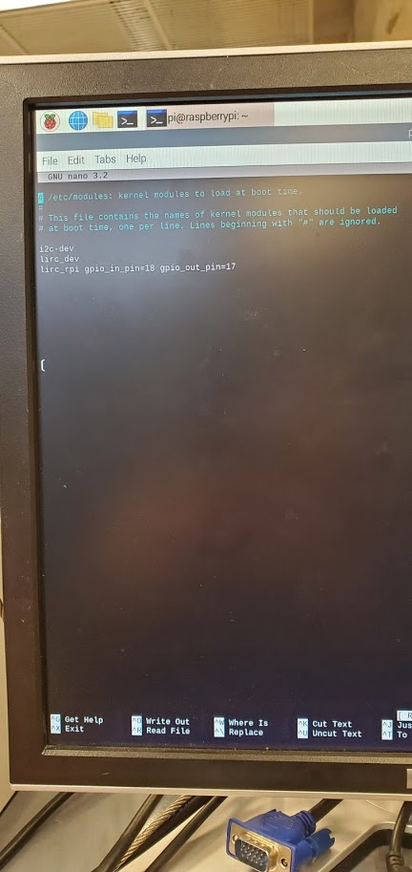

Figure 4: IR configuration file 1

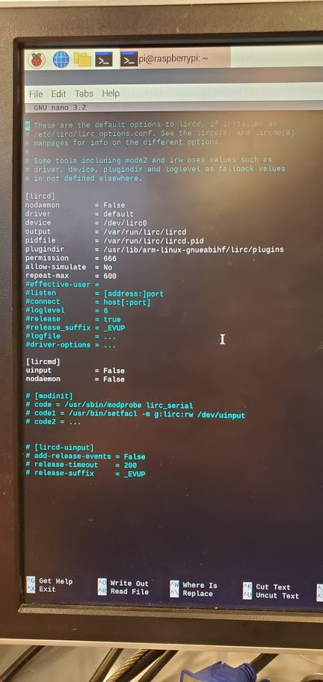

Figure 5: IR configuration file 2

The two configuration files were inserted and modified to set up the Geekworm expansion board. After setting up the Geekworm, the IR receiver was prototyped first. The team wanted to be able to have the Raspberry Pi 3B receive pulses from the universal remote shown in Figure 3. First, LIRC needed to be started from the Raspberry Pi console. This command can be found in Figure 6 below. Then the mode 2 command was used to have the IR receiver begin to receive pulse data from the remote as each of the buttons were pressed. The mode 2 command and the different pulses from each button press are shown in Figure 6 as well.

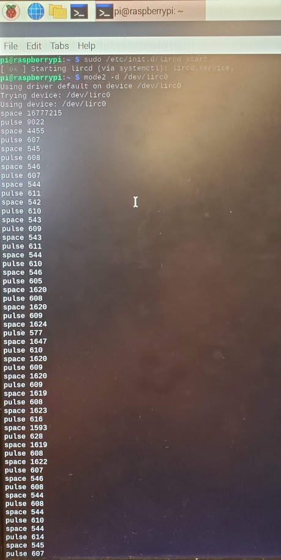

Figure 6: LIRC commands and IR pulses

The list of pulses shown in Figure 6 are from some of the buttons pressed on the remote as it was pointed towards the IR receiver. This protoptyping insured that the Geekworm was working properly and that the universal remote and receiver could communicate between eachother. After validating that this was working as intended, the Geekworm’s IR transmitter was prototyped. The MuteBot system needed to be able to send a mute or volume decrease signal to the television depending on which option was chosen. In order to accomplish this task, a configuration file for the TV remote was needed to be inserted into the LIRC software. Each TV brand has their own specific remote configuration file to commincate between the remote and television. The Westinghouse remote configuration file was found on the LIRC wesite and was used. Figure 7 below shows the Westinghouse configuration file used for the system.

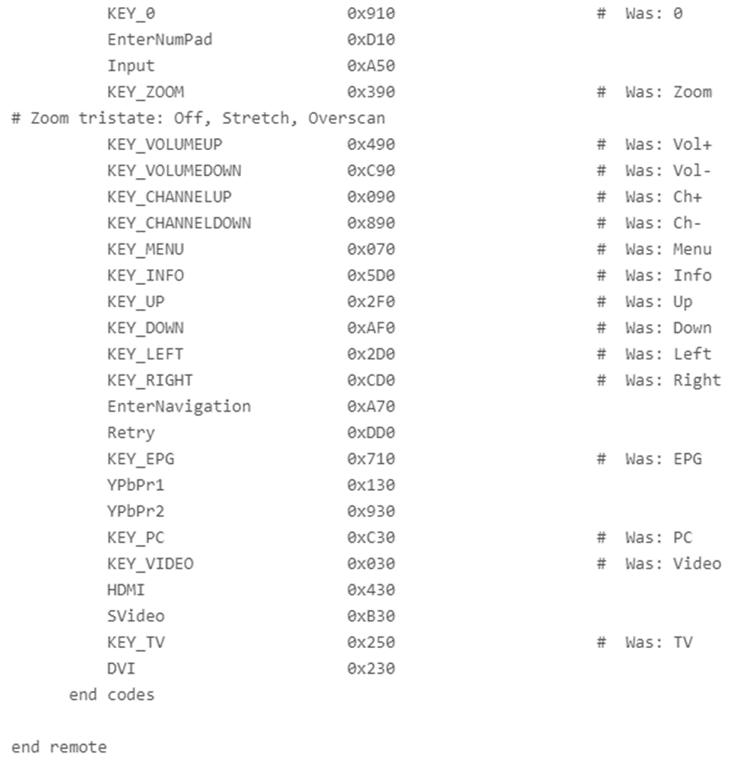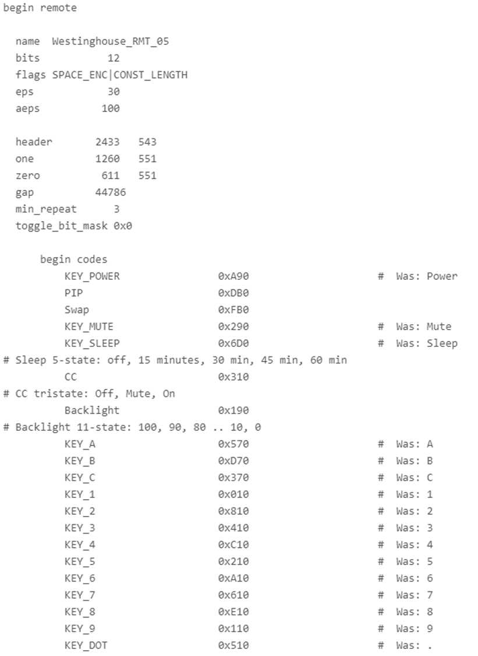

Figure 7: Westinghouse Remote config file

After inserting the Westinghouse remote configuration file, each button press from the universal remote was mapped to each button in the config file. Through prototyping and testing with the television, the configuration file provided by the LIRC website did not work for this specific Westinghouse TV. Future research and prototyping will be needed to either find the correct config file for the specific television being used or create a custom configuration file using the Westinghouse TV remote provided by the customer. Problems that were faced during prototyping are shown in Table 4 below.

Table 4: IR prototyping problems and mitigation

|  |  |
| --- | --- |
| **Problem** | **Mitigation** |
| Problem initializing the Geekworm expansion board with Raspberry Pi | Increased hours of troubleshooting to communicate between IR expansion board and the Raspberry Pi with LIRC software |
| Issues with transmitting signals from Raspberry Pi to the Westinghouse TV | Prototype using the Westinghouse remote to create a custom configuration file |

The list of future plans for the rest of the semester and the spring semester are shown below. These plans will help ensure that we move towards accomplishing the customer and engineering requirements.

1. Create a custom Westinghouse config file with specific button pulses for each command (Power, Mute, Volume Decrease/Increase)
2. Program the Raspberry Pi with LIRC - send a command from the IR Transmitter to mute/volume decrease the Westinghouse TV volume
3. Integrate with Python (TV commercial detection)

## Commercial Detection

After prototyping, commercial detection via audio frequencies has been determined to be the best approach. This is due to the cost and simplicity of working with audio signal processing. The original approach was to use a combination of both digital and audio signal processing. However, using digital image processing has proved to significantly increase the cost of the system as well as the complexity. The cost increase is due to the inflated price of a multi-media processor that can handle the load of digital image processing. To introduce this concept into the system would require learning the concept. All engineers on the project have never worked in this area, therefore due to the time frame it has been omitted. Coaxial signal processing has also been omitted due to the high sampling rate needed in order to accurately process the signals. This makes the main input of the system a 3.5mm audio cable.

With this stated, if the accuracy of commercial detection via audio frequencies proves to be insufficient digital image processing will be considered. Although, the system is planned to have two types of detection methods which is estimated to have an accuracy of at least 80%. The first method is to detect the approach to a silent frame. It has been observed when monitoring two different television programs that there is a slight curve, rather than an abrupt stop, when approaching a silent frame leading to a commercial break. When this is detected this will be the first confirmation of an upcoming commercial. The second method is to detect a large spike in volume than what was previously observed during the regular programming. For this method, the system will monitor an average dB volume through the course of the regular programming. This value will then be compared to the real-time dB values. If a value appears to be abnormally higher than this value than this will trigger the second confirmation of a commercial, which will trigger a mute signal.

To begin prototyping with audio processing, the team worked on two Python scripts in order to gain more familiarity with the language and the libraries needed for audio signal processing. The first script, output depicted in Figure 8, is able read and plot a .wav file based on its magnitude and samples. The second script, whose output is displayed in Figure 9, is able to read and plot an audio source in real-time. Both of these scripts used recommended libraries such as PyAudio, SciPy, MatPlot and NumPy, which will become crucial pieces to the detection program going forward. The team feels as though both of these scripts can be expanded upon next semester to detect silent frames and implement other audio cues to improve the detection accuracy and combat false positives.

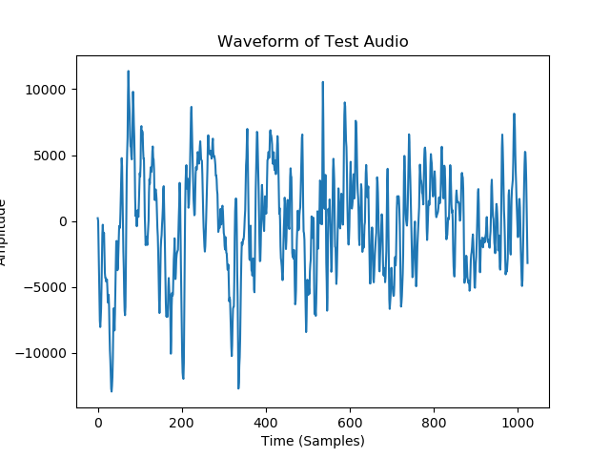

Figure 8: .wav file Python plot

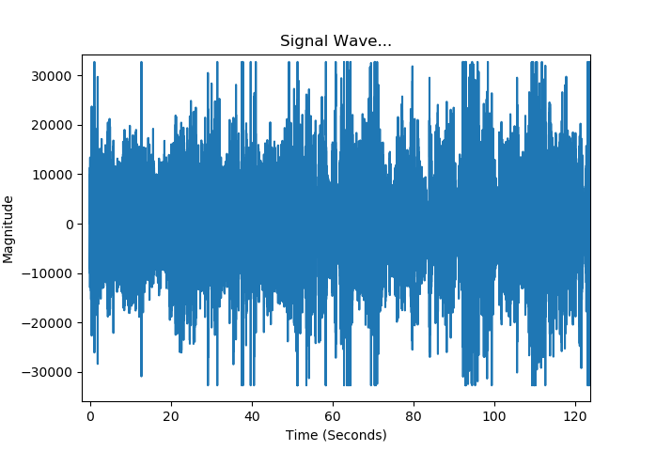

Figure 9: Real-time Python plot

## Solidworks

One major subsystem of the MuteBot is its enclosure and mounting system. Since component decisions have been finalized, a preliminary enclosure can be made that includes a faceplate. Figure 10 provides the preliminary design of the enclosure. The housing was designed with two separate pieces that will be screwed together for simple assembly and access to components inside. When designing the enclosure, the form factor of the Raspberry Pi 3B along with the attached IR expansion board were used to determine the dimensions of the system. The two cylindrical columns will be used to attach the top and the bottom sections together. An alternative solution of containment would be to include 4 screw holes on the corners of the housing. However, this design is an early prototype and the team expects it to go through many changes throughout the following semester.

The list of future plans for the rest of the semester and the spring semester are shown below. These plans will help ensure that we move towards accomplishing the customer and engineering requirements.

1. Create faceplate for IO after components and IO have been finalized.
2. Create an internal mount for the Raspberry Pi 3B so it’s secure in the enclosure.
3. Continue to adjust the dimensions of the housing as design decisions are made.

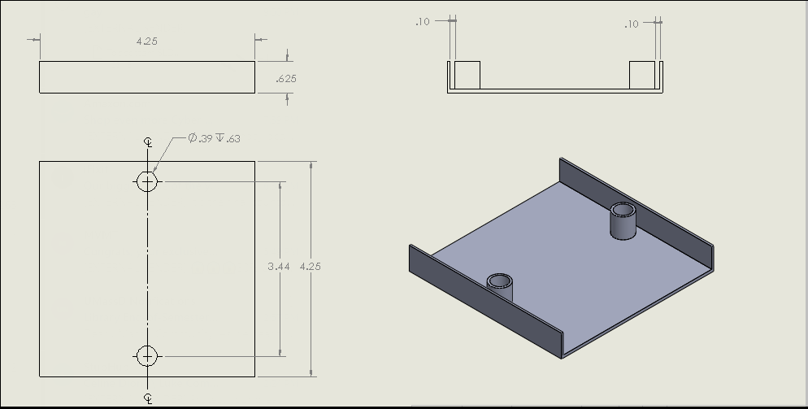

Figure 10: Solidworks Prototyping

# Risk Analysis

Table 5 provides an overview of the risk and potential problems that could arise going forward into next semester along with plans to mitigate them. As the project progresses, these risks and their severities could change based upon design decisions and prototyping.

Table 5: Potential Problems & Risk Analysis

|  |  |
| --- | --- |
| Potential Problems | Risk Factor |
| Commercial Detection by Silent Frames | Low Risk   * Uses 1 detection method, impact on accuracy could increase. * **Mitigation:** * Many online resources for Python Audio Signal Processing. Members have familiarity with Python. Also have resources that explain silent frame detection with tips to improve accuracy. Use multiple audio cues together to improve accuracy. |
| IR transmission and reception via LIRC | Medium Risk   * Unfamiliarity with storing button press pulses and waiting until a commercial is detected before sending the mute or volume decrease command * **Mitigation:** * Online resources are available on how to control a TV with LIRC and an IR transmitter and receiver. Also, more prototyping and testing for each remote button press can be done to limit the risk of failure to control the TV’s audio controls. |
| Python and LIRC integration | Medium Risk   * Members do not have a lot of experience with LIRC. * No experience integrating the two, unknown difficulty * **Mitigation:** * More research needs to be done as well as prototyping. Can use Dr. Viall as a resource with LIRC. |
| Commercial Detection by Black Frames | High Risk   * Greatly increases production costs due to processor speeds * Greatly increases time due to learning curve of digital image processing * **Mitigation:** * Create detection system using audio only first. Therefore the system would not solely rely on the progress made by digital image processing. |

# Schedule

Figures 11-13 provide the final updated schedule for each progress report for the semester. Each task is broken down into a task name, in blue, and the criteria to complete the task, in green. Each task also has estimated hours to complete, estimated cost, actual hours & cost, team member responsible, and the percentage of the task complete. If the task has an engineering requirement associated with it, it is also listed in a separate column.

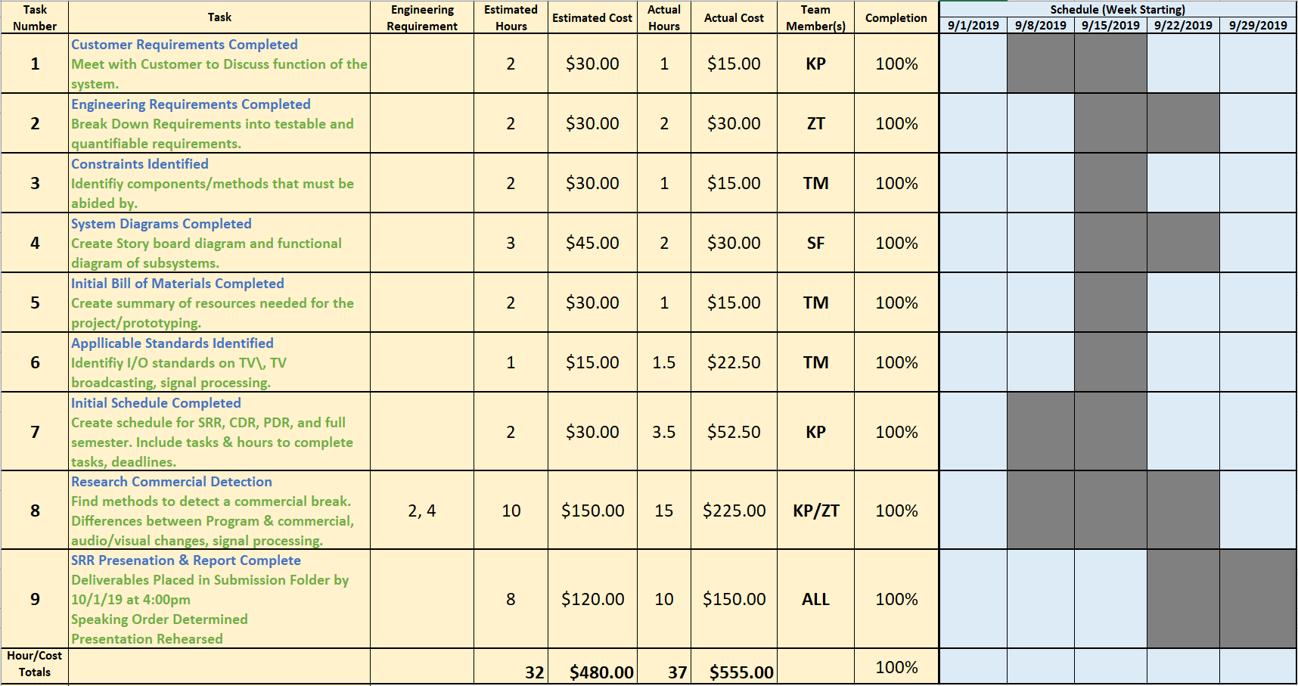**Figure 11: System Requirements Review Schedule**

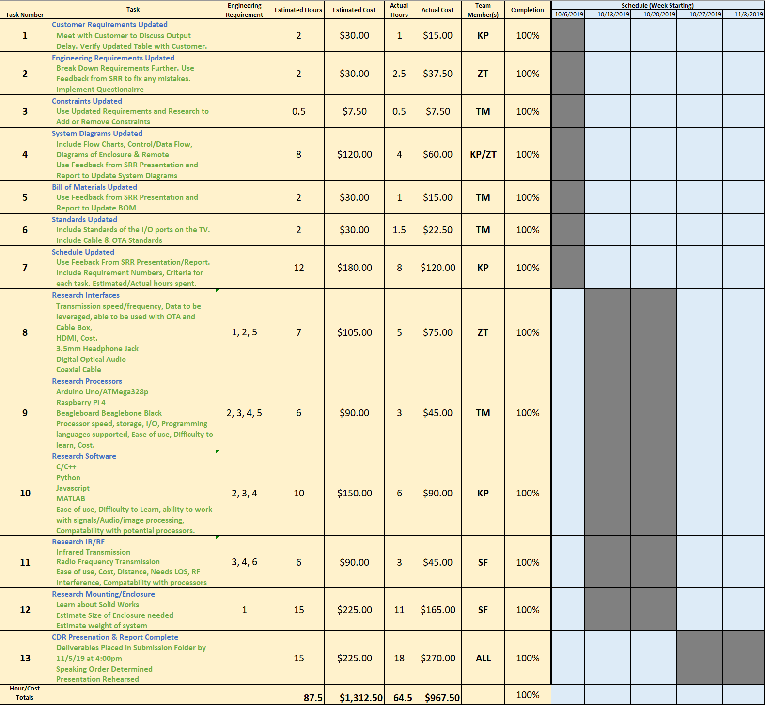**Figure 12: Concept Design Review Schedule**

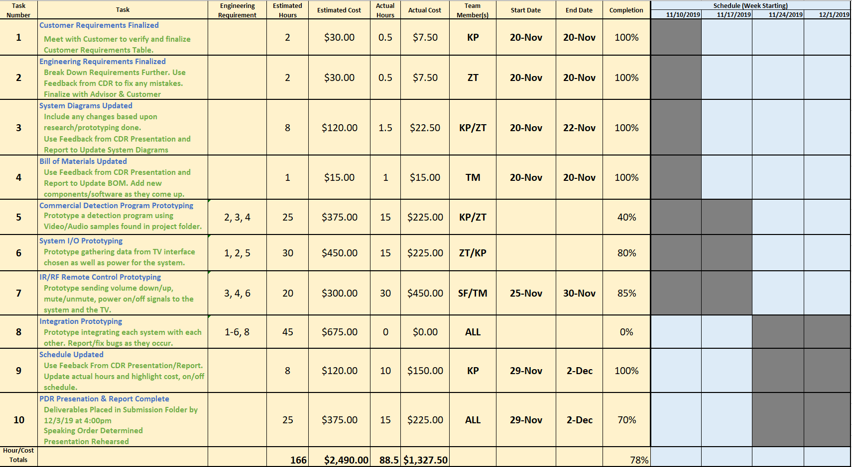**Figure 13: Preliminary Design Review Schedule**

Figures 14-16 combine the three schedules into an overall plan for ECE 457. This plan as been updated along with the other three schedules. The team feels as though it is best to make a plan that does not include work over the winter break because the likelihood of major tasks getting done while on break is low. Rather, based upon this schedule, any work done during the break would be seen as a bonus rather than a requirement. During the semester the team plans to meet weekly on Fridays at 10:00 AM. Advisor meetings with Dr. Rancour will also occur weekly on Wednesdays at 10:00 AM. If members are not able to attend, available members will still meet and discuss the progress made within the week and plan for the following week.

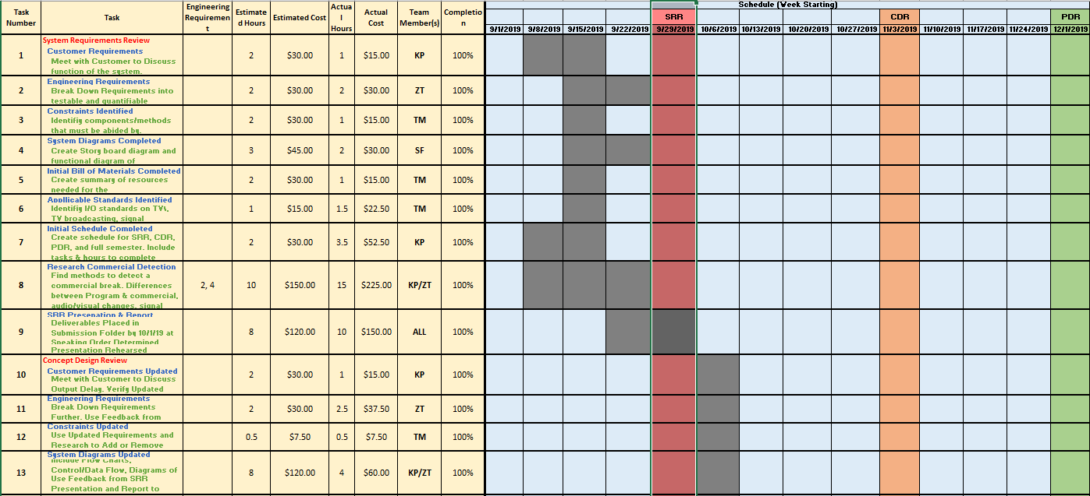

Figure 14: ECE 457 Full Schedule Part 1

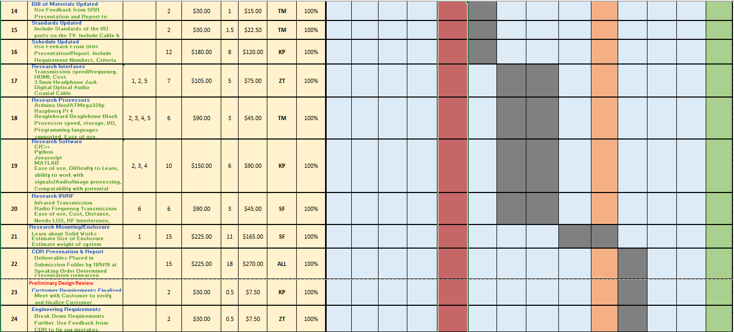

Figure 15: ECE 457 Full Schedule Part 2

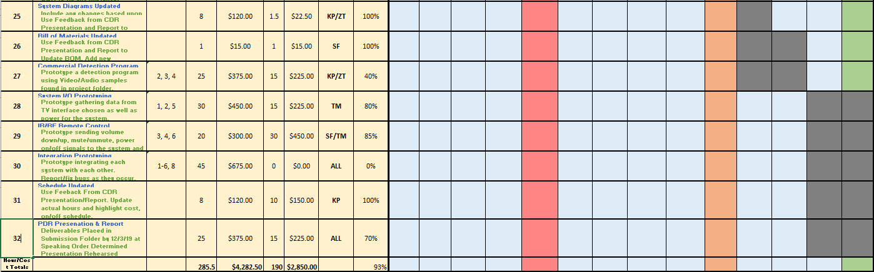

Figure 16: ECE 457 Full Schedule Part 3

# Earned Value

Table 6 provides the estimated and actual hours and cost for the tasks of the SRR, CDR and PDR. In Table 6, the tasks for SRR and CDR have all been completed. The SRR ended up being slightly over budget, but the CDR was completed under budget. The PDR is found to be behind schedule and under budget due to the fact that integration prototyping still needs to be done between the commercial detection and remote-control systems. Overall for the semester, the project is slightly behind schedule, but greatly underbudget. This can change however depending upon the issues faced during integration.

Table 6: Earned Value for the SRR and CDR

|  |  |  |  |  |
| --- | --- | --- | --- | --- |
| Tasks | Estimated Hours | Estimated Cost | Actual Hours | Actual Cost |
| SRR | 32 hrs. | $480 | 37 hrs. | $555 |
| CDR | 87.5 hrs. | $1,312.50 | 64.5 hrs. | $967.50 |
| PDR | 166 hrs. | $2,490 | 88.5 hrs. | $1,327.50 |
| Full Semester | 285.5 hrs. | $4,282.50 | 190 hrs. | $2,850 |

**ECE 457**

**Fall 2019**

**Concept Design Review**

**ECE – 6 TV Auto Commercial Mute System (MuteBot)**

### **Appendix**

